SMART LYNX SMART PARKING MANAGEMENT SYSTEM

MAUREEN MUIGAI-ENE212-0235/2024

1. BACKGROUND
The SmartLynx Smart Parking Management System is a console-based C++ program designed to support real-time administrative and operational functions in a parking facility environment. Many parking lots and garages continue to rely on manual ticketing and record-keeping, which leads to misplaced tickets, slow vehicle retrieval, revenue leakage, and difficulty tracking slot availability. SmartPark provides a straightforward digital alternative that stores essential vehicle entry and exit details, manages parking slot allocation, processes fees based on vehicle type and peak-hour multipliers, and keeps accurate financial records.

The program leverages core Object-Oriented Programming (OOP) principles including inheritance, polymorphism, and encapsulation. An abstract base class Vehicle defines the contract that all vehicle types must implement, while concrete classes Car, Bike, and Truck each override the fee-calculation and slot-type logic. A ParkingLot controller class orchestrates slots, queuing, reservations, and persistent file I/O.

The intended users are parking lot attendants, facility managers, and administrative staff who need a quick and reliable way to handle routine vehicle information and basic parking tasks. The system runs entirely in a terminal/console environment with a text-based menu.

2. FUNCTIONAL REQUIREMENTS
These are the actions the system must perform, derived directly from the implemented source code.

2.1 Vehicle Parking
- Accept vehicle details: plate number, owner name, and entry hour (0–23).
- Identify vehicle type (Car, Bike, Truck) and determine the required slot category.
- Locate and assign the first available matching slot.
- Print a formatted parking ticket showing owner, type, plate, slot number, and entry hour.
- If no matching slot is free, add the vehicle to a FIFO waiting queue.

2.2 Vehicle Exit & Billing
- Search parked vehicles by plate number.
- Compute the parking fee based on duration (exit hour minus entry hour) and vehicle type.
- Apply a peak-hour multiplier when the exit hour is 18:00 or later.
- Display a formatted bill showing vehicle type, plate, and total fee in KES.
- Accumulate the fee into the total revenue counter.
- Save the transaction to transactions.txt (append mode).
- Free the vacated slot and trigger the waiting-queue processor.
- Deallocate the vehicle object from the heap (delete).

2.3 Waiting Queue Management
- Maintain a std::queue<Vehicle*> for vehicles that cannot be parked immediately.
- On every vehicle exit, automatically check and assign the freed slot to the next waiting vehicle.
- Notify the user when a waiting vehicle is assigned a slot automatically.

2.4 Slot Management
- Initialise 10 slots at startup: 3 Small (IDs 1–3), 4 Medium (IDs 4–7), 3 Large (IDs 8–10).
- Track occupancy status (true/false) per slot.
- Expose slot type and ID for matching and display purposes.
- Free the correct slot type upon vehicle exit.

2.5 Reservation
- Accept a plate number and generate a random reservation ID prefixed with 'RES'.
- Store the reservation in a std::vector<Reservation>.
- Print the reservation ID to the console for the user's reference.

2.6 Status Dashboard
- Count and display available vs occupied slots across all types.
- Show the number of vehicles currently in the waiting queue.
- Display the cumulative total revenue collected (KES).

2.7 File Persistence
- Append each completed transaction to transactions.txt using std::ofstream.
- Record vehicle type, plate number, and fee per line, pipe-delimited.

3. SYSTEM DESIGN

3.1 System Architecture
The system follows a three-layer architecture implemented entirely in a single C++ translation unit:

Presentation Layer (User Interface): The main() function renders a text-based menu (do-while loop) and reads user input via std::cin. It maps numeric choices to actions.

Business Logic Layer (Application): The ParkingLot class implements all core business rules — slot matching, queue management, fee calculation delegation, reservation generation, and revenue tracking.

Data Storage Layer: File-based persistence via std::ofstream. Transaction records are appended to transactions.txt without a relational database engine.
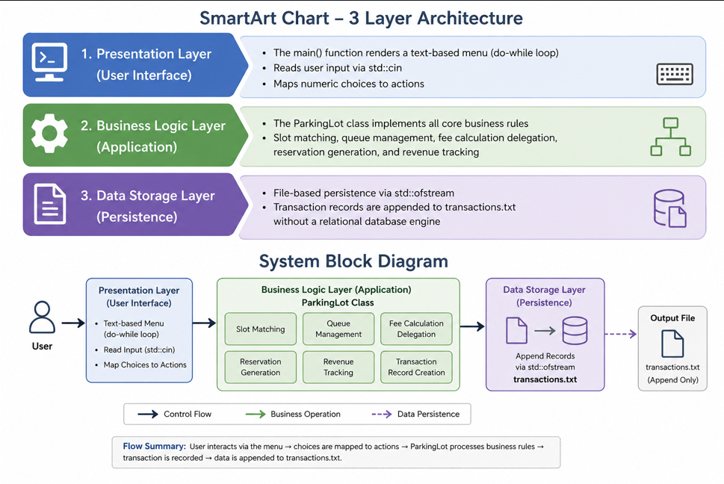

3.2 Class Hierarchy & Responsibilities

Class / Entity | Type | Parent | Purpose
Vehicle | Abstract | — | Base class for all vehicle types; defines interface
Car | Concrete | Vehicle | Handles medium-slot cars with KES 100/hr base rate
Bike | Concrete | Vehicle | Handles small-slot bikes with KES 50/hr base rate
Truck | Concrete | Vehicle | Handles large-slot trucks with KES 200/hr base rate
ParkingSlot | Utility | — | Tracks slot ID, type (Small/Medium/Large), occupancy
Reservation | Data | — | Stores a reservation ID and linked plate number
ParkingLot | Controller | — | Orchestrates slots, vehicles, queue, revenue & file I/O

Slot matching is strict: a Car can only occupy a Medium slot, a Bike a Small slot, and a Truck a Large slot. This is enforced by comparing getRequiredSlot() against slot.getSlotType() in parkVehicle() and freeMatchingSlot().

3.3 Fee Calculation Model

Vehicle | Base Rate (KES/hr) | Peak Multiplier (≥ 18:00) | Min Duration
Car | 100 | ×1.5 → KES 150/hr | 1 hour
Bike | 50 | ×1.2 → KES 60/hr | 1 hour
Truck | 200 | ×2.0 → KES 400/hr | 1 hour

Duration is computed as exitHour − entryHour. If the result is zero or negative (same-hour or data error), it defaults to 1 hour. Peak-hour surcharge activates when exitHour ≥ 18, multiplying the base rate before computing the final fee. Fee formula:

fee = duration × rate
where rate = baseRate × peakMultiplier (if exitHour >= 18)

Example — Car, entry 09:00, exit 20:00:
duration = 11 hrs | rate = 100 × 1.5 = 150 | fee = KES 1,650

4. CODE WALKTHROUGH

4.1 Abstract Base Class — Vehicle
The Vehicle class is declared abstract via a pure virtual function. It encapsulates the three shared attributes of every vehicle and provides getters so subclasses and the ParkingLot can access them without breaking encapsulation.

class Vehicle {
protected:
string plateNumber;
string ownerName;
int entryHour;
public:
Vehicle(string plate, string owner, int hour);
virtual double calculateFee(int exitHour) = 0; // pure virtual
virtual string getVehicleType() = 0; // pure virtual
virtual string getRequiredSlot() = 0; // pure virtual
string getPlateNumber();
string getOwnerName();
int getEntryHour();
virtual ~Vehicle() {}
};

Key design decisions:
- protected attributes allow subclass access without public exposure.
- Pure virtual destructor pattern: the virtual destructor ensures the correct subclass destructor is called when delete is used through a base-class pointer.
- Three pure virtuals enforce a contract: every concrete subclass must declare its type string, slot requirement, and fee formula.

4.2 Concrete Vehicle Subclasses

Car
double Car::calculateFee(int exitHour) {
int duration = exitHour - entryHour;
if(duration <= 0) duration = 1;
double rate = 100;
if(exitHour >= 18) rate *= 1.5;
return duration * rate;
}
string Car::getVehicleType() { return "Car"; }
string Car::getRequiredSlot() { return "Medium"; }

Bike
double Bike::calculateFee(int exitHour) {
int duration = exitHour - entryHour;
if(duration <= 0) duration = 1;
double rate = 50;
if(exitHour >= 18) rate *= 1.2;
return duration * rate;
}
string Bike::getVehicleType() { return "Bike"; }
string Bike::getRequiredSlot() { return "Small"; }

Truck
double Truck::calculateFee(int exitHour) {
int duration = exitHour - entryHour;
if(duration <= 0) duration = 1;
double rate = 200;
if(exitHour >= 18) rate *= 2;
return duration * rate;
}
string Truck::getVehicleType() { return "Truck"; }
string Truck::getRequiredSlot() { return "Large"; }

4.3 ParkingSlot
A lightweight value-type class that tracks a slot's identity and state:

class ParkingSlot {
int slotID;
string slotType; // "Small" | "Medium" | "Large"
bool occupied; // false by default
public:
bool isOccupied();
void occupySlot();
void freeSlot();
string getSlotType();
int getSlotID();
};

4.4 ParkingLot — Core Methods

Method | Parameters | Returns | Description
parkVehicle(Vehicle*) | vehicle pointer | void | Finds matching free slot; parks or queues vehicle
exitVehicle(string, int) | plate, exitHour | void | Calculates fee, bills, frees slot, drains queue
freeMatchingSlot(string) | slot type string | void | Frees first occupied slot of given type
processWaitingQueue() | — | void | Assigns freed slot to first matching queue vehicle
createReservation(string) | plate number | void | Generates RES+random ID and stores Reservation
displayStatus() | — | void | Prints slot counts, queue size, total revenue
generateTicket(Vehicle*, int) | vehicle, slotID | void | Prints formatted entry ticket to console
saveTransaction(Vehicle*, double) | vehicle, fee | void | Appends transaction line to transactions.txt

4.5 Waiting Queue Flow
The waiting queue uses std::queue<Vehicle*> (FIFO). The flow is:

// On parkVehicle() — no free slot found:
waitingQueue.push(vehicle);

// On exitVehicle() — after freeing slot:
processWaitingQueue();
→ peek front of queue
→ if matching slot now available: pop & park automatically
→ notify attendant via console output

4.6 Main Menu Loop

The program entry point uses a do-while loop driven by user input:

Option | Label | Action Triggered
1 | Park Car | Creates a Car object and calls parkVehicle()
2 | Park Bike | Creates a Bike object and calls parkVehicle()
3 | Park Truck | Creates a Truck object and calls parkVehicle()
4 | Exit Vehicle | Calls exitVehicle() with plate and exit hour
5 | Create Reservation | Calls createReservation() to generate RES ID
6 | View Parking Status | Calls displayStatus() for counts and revenue
0 | Exit | Terminates the do-while loop and closes system

int main() {
srand(time(0)); // seed for reservation ID generation
ParkingLot parkingLot;
int choice;
do {
// print menu ...
cin >> choice;
// handle choice 1-6 or 0 to exit
} while(choice != 0);
return 0;
}

5. DATA DESIGN

5.1 Overview
This section describes the data types managed by the system and how data flows between components. The system uses in-memory data structures (vectors, queue) during runtime, with append-only file persistence for completed transactions.

5.2 Data Types by Module

1. User Authentication Data
- Receives: Username, password (future extension; not yet implemented in code).
- Processes: Credential verification.
- Outputs: Login status (success / failure).

2. Vehicle Data
- Receives: Plate number (string), owner name (string), entry hour (int, 0–23), vehicle type (derived from menu choice).
- Processes: Validation of entry hour range; object construction (new Car / Bike / Truck).
- Outputs: Vehicle object stored in parkedVehicles vector or pushed to waitingQueue.

3. Parking Slot Data
- Receives: Slot ID (int), slot type (string: Small / Medium / Large), occupancy status (bool).
- Processes: Type-matching against vehicle requirements; occupancy toggle.
- Outputs: Slot assignment confirmation; updated occupied / available counts for dashboard.

4. Billing / Transaction Data
- Receives: Vehicle pointer (type, plate, entryHour) and exit hour (int).
- Processes: duration = exitHour − entryHour; applies base rate and peak multiplier.
- Outputs: Fee value (double, KES); console bill printout; appended line in transactions.txt.

5. Reservation Data
- Receives: Plate number string.
- Processes: Random ID generation via rand() % 10000 seeded with time(0).
- Outputs: Reservation object in reservations vector; printed Reservation ID to console.

6. OOP CONCEPTS APPLIED

6.1 Abstraction
The Vehicle class hides implementation details behind a clean interface. Callers of calculateFee() do not need to know the rate logic — they only call the method and receive a double. The abstract class enforces this contract through pure virtual functions.

6.2 Inheritance
Car, Bike, and Truck all inherit from Vehicle, reusing the constructor and attribute declarations. Each subclass only adds or overrides what is unique to that vehicle type, avoiding code duplication.

6.3 Polymorphism
The parkedVehicles vector holds Vehicle* base-class pointers. When the ParkingLot calls vehicle->calculateFee(exitHour) or vehicle->getVehicleType(), C++ virtual dispatch automatically routes to the correct subclass method at runtime. This allows ParkingLot to handle all vehicle types uniformly without switch-case logic.

6.4 Encapsulation
ParkingSlot keeps slotID, slotType, and occupied as private fields. State is only changed through occupySlot() and freeSlot() methods. Similarly, Vehicle's attributes are protected — not public — preventing accidental external modification.

6.5 Dynamic Memory Management
Vehicle objects are allocated on the heap (new Car, new Bike, new Truck) so they can be stored as base-class pointers and persist across function calls. The ParkingLot destructor and exitVehicle() call delete to prevent memory leaks.

7. LIMITATIONS & FUTURE WORK

7.1 Current Limitations
- Hours-only time resolution — does not support minutes or real timestamps.
- No persistent vehicle/slot state across restarts — only transactions are saved to file.
- Reservation system does not actually hold/block a slot; it is informational only.
- No user authentication is implemented despite being mentioned in the architecture.
- Owner names with spaces are not handled (cin >> reads only one token).
- rand() without proper seeding uniqueness may produce duplicate reservation IDs.

7.2 Proposed Enhancements
- Replace hour-based timing with system timestamps (std::chrono) for minute-level precision.
- Persist slot and vehicle state to a JSON or CSV file so data survives restarts.
- Link reservations to actual slot holds with expiry timers.
- Add an admin login module with hashed password verification.
- Replace cin >> for names with getline() to support multi-word input.
- Develop a CGI-based web front-end to move from console to browser UI.

